Please describe your research proposal by filling out this proposal upload template. Before starting, carefully read the instructions below:

- The proposal upload should not exceed 15 pages, including figures but not including references. Any excess pages will not be evaluated.
- Please respect the following formatting constraints: Verdana, at least font size 9, margins (2.5 cm side and 2.5 cm top and bottom), single line spacing.
- Please note that the number of pages per section is indicative
- All text highlighted in grey should be removed.
- Fill out the name of the project leader and project number in the footer of all pages of the proposal upload.
- Please upload your research proposal as a PDF Document.
- The proposal upload is part of the KWF application form. Please take note of the additional GMS fields that are required for submitting the full project proposal.

Proposal upload

Background & relevance: (1-2 pg)
Please provide a summary of the relevant literature.
Please describe the relevance of your research, preferably on the basis of the following subjects:
- problem description (unmet need)
- solution / research direction (description of the envisioned solution).

Aim(s):
Please describe the aim(s) of this research proposal, the primary and secondary research questions, and to what extent this project contributes to the solution of the problem / the research direction.

Preliminary data of own research:
Please specify the results of preliminary research (including pilot studies) undertaken by you or the research team that led to the current project proposal. Refer to the preliminary research that has already been/or is in the process of being published and abstracts.

Plan of investigation: (4-6 pg)
Please explain how the activities of your overall work plan are divided across 1-3 work packages and how the work packages are interconnected. A work package consists of a unit of coherent work/activities and is clearly distinguishable from other work packages. For each work package, please include all subheaders. Please restrict the number of work packages to a minimum.

Work package 1 – Title
Name responsible person:
Work package starts in month:
Work package duration:
Criteria for success:

Objective(s)
An objective is a specific result that a person or system aims to achieve within a time frame and with available resources

Description of work
Please describe the methods and techniques that will be used.
Milestone(s)
Milestones are defined as critical points in time to ascertain that sufficient and successful progress has been made in your project; 3-6 milestones per work package will suffice. It is obligatory to formulate at least one milestone per work package.
Work package 2 – Title (You may remove this work package)
Name responsible person:
Work package starts in month:
Work package duration:
Criteria for success:

Objective(s)
Description of the work
Milestone(s)

Work package 3 – Title (You may remove this work package)
Name responsible person:
Work package starts in month:
Work package duration:
Criteria for success:

Objective(s)
Description of the work
Milestone(s)

GANTT Chart
Please provide a GANTT chart showing: the duration of the work packages, and the timeframe necessary to reach the milestones. Please use the format below as an example.

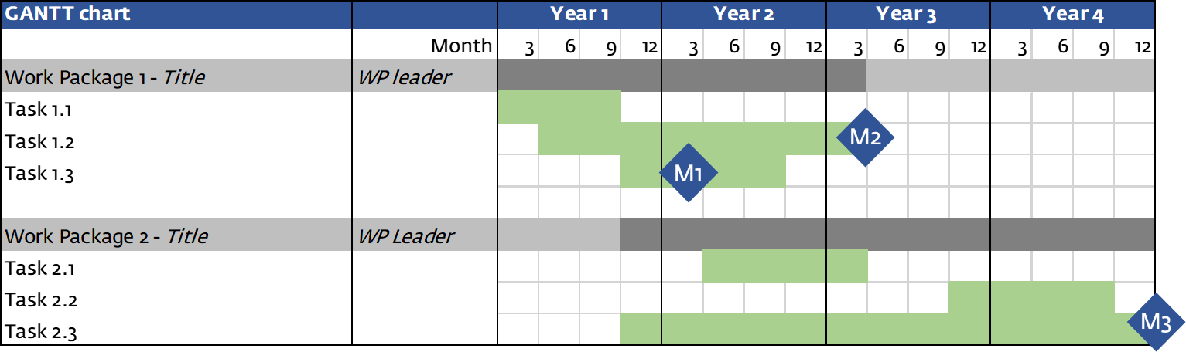

Statistics and data management (1-2 pg)
Statistics
Please describe the relevant statistics: if applicable include power calculation and include a statistical analysis strategy.

Data management
Please provide a data management plan to describe how you will approach data management and -sharing, quality control, bioinformatics, data accessibility, or any other specific data analysis methods you intend to use. In accordance with the funding conditions of KWF Kankerbestrijding 2022, the lead institute is required to work according to the FAIR data principles: Legislation, Findable, Accessible, Interoperable and Reusable. Describe how you are adhering to the FAIR principles

Please refer to the guidelines for detailed instructions.

Development (1-2 pg)
Development plan
For KWF it is essential that obtained knowledge, skills and technology are made available for patients and the public. Please describe which steps and actions are needed to realize implementation of the innovation/new method. Which actions will be taken during this project? And which after successful completion of this project? Please include the actions taken during this project in your plan of investigation.

Describe the following topics:
- Applicability and wide availability in clinical practice,
- IP strategy,
- Potential commercialization,
- Legislation,
- Reimbursement,
- Stakeholders,
- Risks and opportunities.

Please refer to the guidelines for detailed instructions and information about these topics.

